**System Testing:**

Testing the software / product according to client requirements.

Different types of system testing:

* GUI Testing
* Usability testing
* Functional testing
* Non- Functional testing

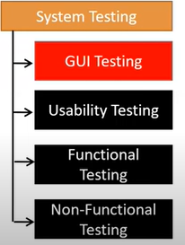

**GUI testing:**

* Graphical user interface testing is a process of testing the user interface of an application.
* A GUI includes all the elements such as menus, checkbox, colour, font, images etc

**GUI testing check list:**

* Testing the size, width, height of elements
* Testing of error message that are getting displayed
* Testing different section of the screen
* Testing of font whether it is readable or not
* Testing of screen in different resolution with the help of zooming in and zooming out
* Testing the alignment of the texts and other elements like icon, buttons etc
* Testing the colours of the font
* Testing whether the image has good clarity or not
* Testing the alignment of the images
* Testing of the spelling
* The user must not get frustrated while using the system interface
* Testing whether the interface is attractive or not
* Testing of the scroll bars according to the size of the page
* Testing the disabled field if any
* Testing the size of the images
* Testing the heading whether it is properly aligned or not
* Testing the colour of the hyperlink
* Testing all UI elements textbox, checkbox, button etc

**Usability testing:**

* During this testing validates application provided context sensitive help or not to user
* Checks how easily the end user are able to understand and operate the application is called usability testing

**Functional testing:**

* Functionality is nothing but behaviour of application.
* Functional testing talks about how your feature should work.

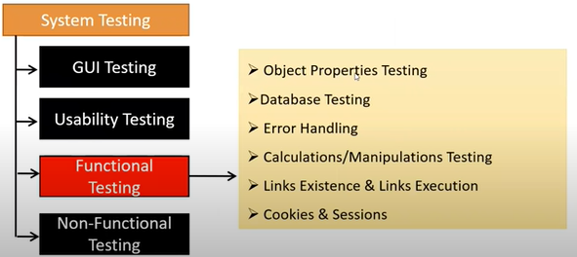

**1.Object properties testing:**

Check the properties of objects present on the application.

Ex: enable, disable, visible, focus…

**2.Database testing:**

Testing performed on the database operations with respect to user operation is called as database testing. In database testing we will test UI side request and queries executing on database side. This type of performing testing on UI side and backend logic is called as **grey box testing**.

**Grey box testing** is nothing but tester who perform both white box and black box testing.

Basically we test normal DML operations such as (insert, update, delete, select)

But if we want to test below things then we must be perfect with database in depth.

Like table and column level validation (column type, column length etc)

Relation b/w tables (Normalization)

Functions, procedures, triggers, indexes, views etc

**3. Error handling testing:**

Tester verifies the error messages while performing incorrect actions on the application.

Error messages should be readable.

User understandable/ simple language.

**4. Calculations and manipulation testing:**

Tester should verify the calculations.

**5. Link existence and link execution:**

Where exactly the links are placed --- > link existence

Links are navigating to proper page or not ---- > list execution

Internal links --- > navigating to different section on the same page

External links --- > navigating to different page

Broken link --- > no action performed but can be used for feature usage

**6. Cookies & sessions:**

**Cookies** are temporary file created by browser while browsing the web pages through internet.

**Sessions** are time slots created by server. Sessions will be expired after sometime ( if you are idle for some time).

**Non-Functional testing:**

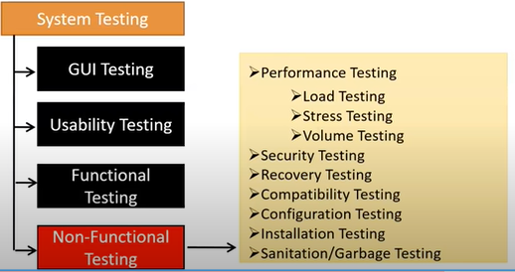

1. **Performance testing --- > speed of the application:**

* **Load testing**
* **Stress testing**
* **Volume testing**

**Load:** gradually increasing the load on the application then check the speed of the application.

**Stress:** suddenly increase/decrease the load on the application and check the speed of the application.

**Volume:** check how much data is able to handle by the application.

**2.Security testing ---- > how to secure our application.**

**Authentication --->** Users are valid or not

**Authorization --- >** permission for valid user.

**3.Recovery testing:**

Check the system change abnormal to normal.

**4.Compatibility testing:**

* Forward compatibility
* Backward compatibility
* Hardware compatibility (configuration testing)

**5. Installation testing:**

Check screens are clear are not.

Simple or not

Un-installation

Screens navigation

**6. sanitation/garbage testing:**

If any application provides features/ functionality then we consider them as bug.

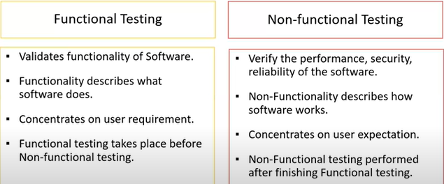

**Software testing terminology:**

**Regression testing:**

* Testing conducts on modified build to make sure there will not be impact on existing functionality because of changes like adding/ deleting/ modifying features.
* **Unit regression testing:**

Testing only the changes/ modifications done by developer.

* **Regional regression testing:**

Testing the modified module along with the impacted module.

**Impact Analysis** meeting conducts to identify impacted modules with QA and Dev.

* **Full Regression:**

Testing the main feature and remaining part of the application.

Ex; Dev has changes in many modules, instead of identifying the impacted modules we perform one round of full regression.

**Re-Testing:**

Whenever the developer fixed a bug, tester will test the bug fix is called re-testing.

Tester close the bug if it worked otherwise reopen and send to developer.

To ensure that defects which where found and posted in the earlier build were fixed or not in the current build.

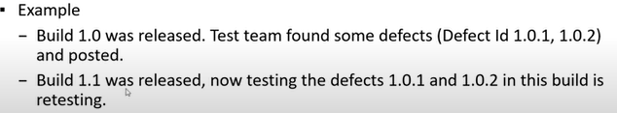

**Smoke testing and sanity testing:**

Smoke and sanity testing come into picture after the build is released.

